- 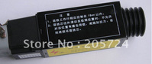

Schindler brake solenoid ID897200
0918.414.313 / piece
Recent Order(1)

- 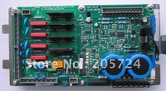

QKS910Q 590769
0918.414.313 / piece

- 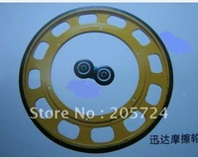

Schindler friction wheel 578X330X30
0918.414.313 / piece
- 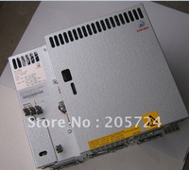

Schindler inverter VF22BR
0918.414.313 / piece

- 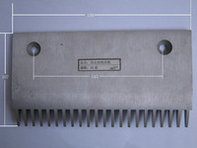

9300 Escalator comb plate
0918.414.313 / piece

- 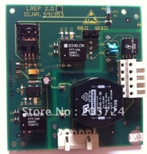

Schindler ID591353
0918.414.313 / piece
- 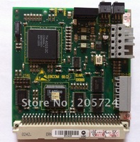

Schindler ID590866
0918.414.313 / piece

- 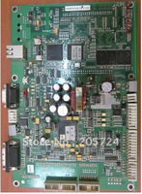

Schindler 59400351
0918.414.313 / piece

- 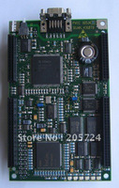

Schindler 431078
0918.414.313 / piece
- 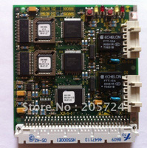

Schindler ID590888
0918.414.313 / piece

- 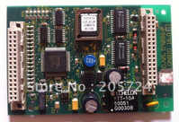

Schindler ID590864
0918.414.313 / piece

- 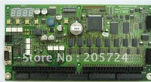

ID 398765
0918.414.313 / piece
- 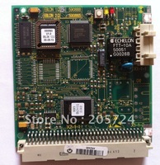

Schindler ID590865
0918.414.313 / piece

- 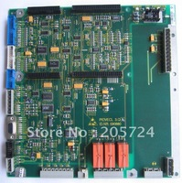

Schindler 590880
0918.414.313 / piece

- 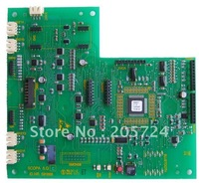

Schindler inverter 591888
0918.414.313 / piece
- 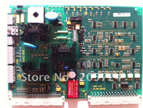

Schindler ID591442
0918.414.313 / piece

- 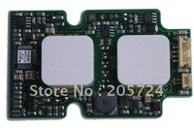

Schindler inverter 591874
0918.414.313 / piece

- 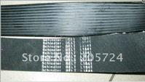

Schindler V-belt
0918.414.313 / piece
- 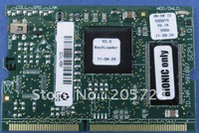

Schindler ID591887
0918.414.313 / piece

- 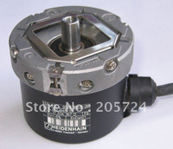

Schindler Encoder ECN413 2048 16S15-2K ID 317945 53
0918.414.313 / piece

- 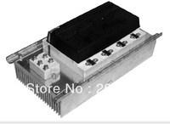

Schindler inverter VF85BR
0918.414.313 / piece

- 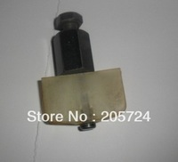

door slide
0918.414.313 / piece
Min. Order : 20 pieces

- 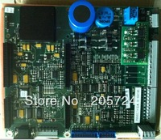

Schindler ID594105
0918.414.313 / piece
- 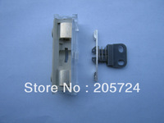

Schinder door contactor
0918.414.313 / piece

- 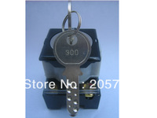

Schindler 300 DOOR KEY
0918.414.313 / piece
Min. Order : 10 pieces

- 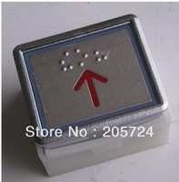

Schindler Button
0918.414.313 / piece
- 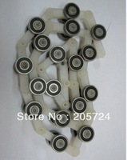

Schindler 9300 Escalator Reverse Chain
0918.414.313 / piece

- 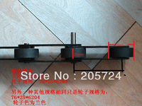

Escalator Step Driving chain
0918.414.313 / millimeter
Min. Order : 133 millimeter

- 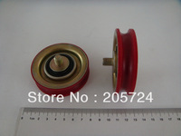

V30 Door Roller
0918.414.313 / piece
Min. Order : 20 pieces

