* 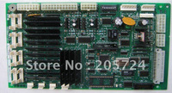

Sigma DCL-243

**0918.414.313** / piece

* 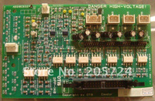

Sigma DPP-140

**0918.414.313** / piece

* 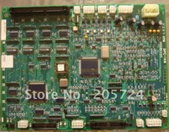

Sigma DPC-140

**0918.414.313** / piece

* 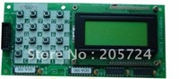

Sigma DOA-100

**0918.414.313** / piece

* 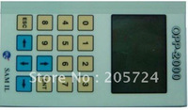

Sigma DPP-2000

**0918.414.313** / piece

* 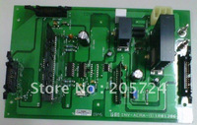

INV ACRA-1 1R01306-B

**0918.414.313** / piece

* 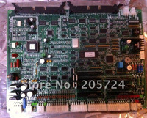

DOR-232

**0918.414.313** / piece

* 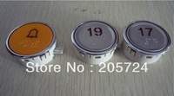

LG button round

**0918.414.313** / piece

Min. Order : 10 pieces

* 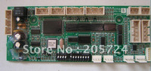

Sigma DHG-162

**0918.414.313** / piece

* 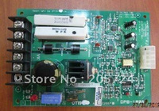

Sigma DPB-100A

**0918.414.313** / piece

* 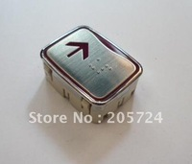

LG push button

**0918.414.313** / piece

* 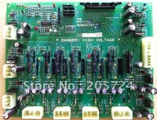

DPP-110

**0918.414.313** / piece

* 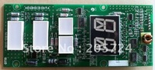

DHI-201N

**0918.414.313** / piece

* 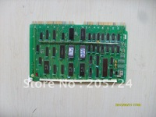

LG MCPU-3A

**0918.414.313** / piece

* 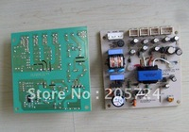

OTIS Sigma power supply

**0918.414.313** / piece

* 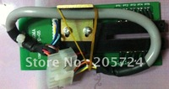

Sigma DPD-05

**0918.414.313** / piece

* 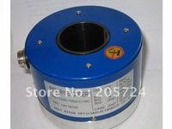

Sigma encoder

**0918.414.313** / piece

* 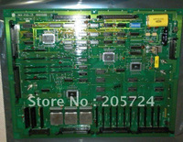

LG INV-FIO

**0918.414.313** / piece

* 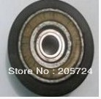

LG roller 80x29x6202x2

**0918.414.313** / piece

Min. Order : 20 pieces

* 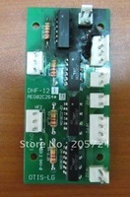

Sigma DHF-121

**0918.414.313** / piece

* 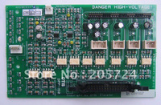

Sigma DPP-150

**0918.414.313** / piece

* 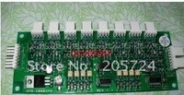

Sigma OPB-2000 SPA & IMB_LANTERN

**0918.414.313** / piece

* 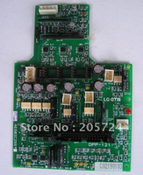

Sigma DPP-121

**0918.414.313** / piece

* 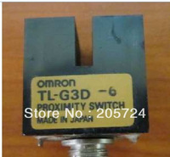

Sensor TL-G3D

**0918.414.313** / piece

* 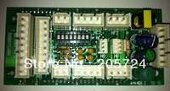

DHG-150

**0918.414.313** / piece

* 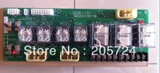

DOR-131

**0918.414.313** / piece

* 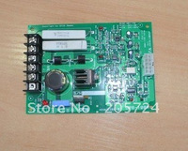

OTIS-Sigma DPB-100

**0918.414.313** / piece

* http://i01.i.aliimg.com/wsphoto/v0/806734731_1/Sigma_square_button.jpg_200x200.jpg

Sigma square button

**0918.414.313** / piece

Min. Order : 10 pieces

* 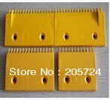

LG demarcation cleat

**0918.414.313** / piece

* 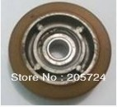

[LG roller 80x22X6202](http://www.aliexpress.com/store/product/LG-roller-80x22X6202/205724_694500634.html)

**0918.414.313** / piece

* 

LG Escalator cleat

**0918.414.313** / piece

Min. Order : 50 pieces

* 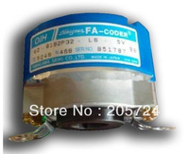

Encoder TS5246N468

**0918.414.313** / piece