- 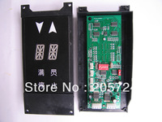

OTIS DAA26800G2
0918.414.313 / piece

- 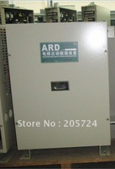

Emergency Landing Device, Auto Rescue Device
0918.414.313 / piece

- 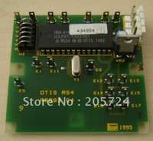

Otis RS4
0918.414.313 / piece
- 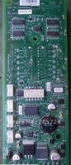

Otis DAA26800G2
0918.414.313 / piece

- 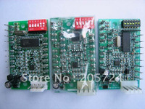

Otis RS5
0918.414.313 / piece

- 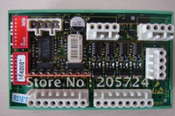

Otis RS18
0918.414.313 / piece
- 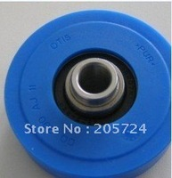

OTIS Roller 76x19x6203
0918.414.313 / piece

- 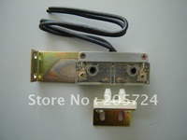

OTIS Door Switch
0918.414.313 / piece

- 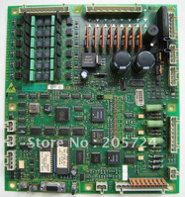

OTIS LCB-II
0918.414.313 / piece
- 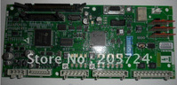

OTIS GDCB AEA26800AKT2
0918.414.313 / piece

- 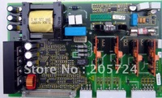

OTIS GCA26800J1
0918.414.313 / piece

- 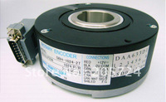

encoder SBH2-1024-2T-30-050-16
0918.414.313 / piece
- 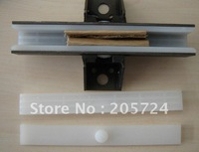

OTIS Guide shoes
0918.414.313 / piece

- 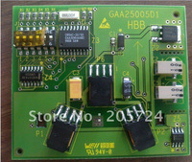

OTIS HBB GAA25005D1
0918.414.313 / piece

- 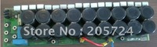

OTIS GBA26800P1
0918.414.313 / piece
- 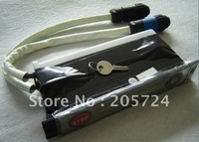

OTIS GAB26220BD4
0918.414.313 / piece

- 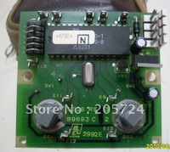

Otis RS3
0918.414.313 / piece

- 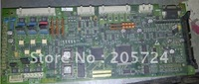

GCA26800KF1
0918.414.313 / piece
- 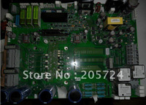

OTIS HVIB 26800AAZ
0918.414.313 piece

- 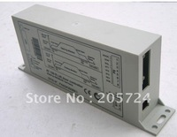

Otis AT120 - FAA24350BK1
0918.414.313 / piece

- 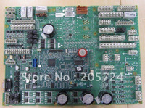

OTIS GBA26800KLC3
0918.414.313 / piece
- 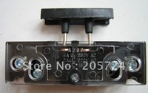

Door Switch AZ-06
/0918.414.313 piece

- 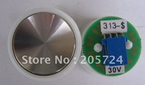

OTIS Button
0918.414.313 / piece

- 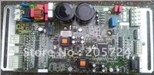

Otis DCSS5-E(GBA24353K1)
0918.414.313 / piece
- 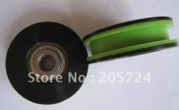

OTIS Roller 56X16mm
0918.414.313 / piece

- 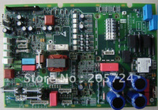

OTIS GCA26800KG4
0918.414.313 / piece

- 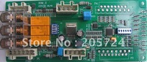

OTIS SOM-II
0918.414.313 / piece
- 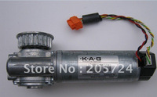

OTIS AT120 motor
0918.414.313 / piece

- 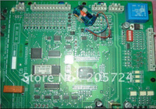

Otis GAA26800AR2
0918.414.313 / piece

- 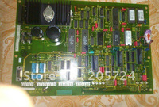

OTIS JYA9693D2
0918.414.313 / piece
- 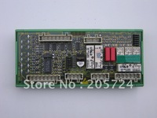

Otis GBA26810A2
0918.414.313 / piece

- 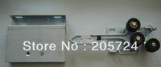

Otis Landing lock
0918.414.313 / piece

- 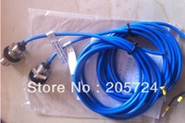

OTIS Sensor SLD2-12GM-WH1A
0918.414.313 / piece
- 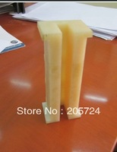

OTIS guide shoes
0918.414.313 / piece

- 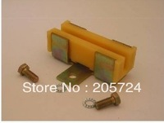

Guide shoes
0918.414.313 / piece

- 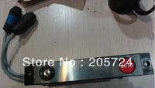

OTIS Escalator indicator
0918.414.313 / piece
- 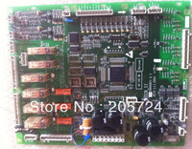

OTIS ECB_II GCA26800AY1
0918.414.313 / piece

- 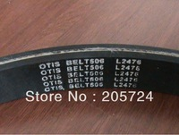

OTIS Press Belt
0918.414.313 / piece

- 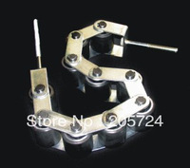

Handrail press
0918.414.313 / piece
- 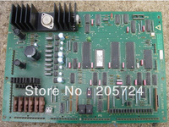

Otis LB 09673
0918.414.313 / piece

- 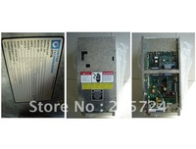

Otis DBSS OVF1 (OVF30)
0918.414.313 / piece

- 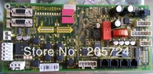

OTIS GCA26800BB1
0918.414.313 / piece
- 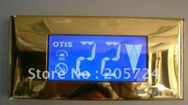

OTIS LCD display
0918.414.313 / piece

- 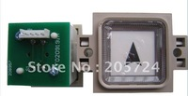

OTIS BR34 button
0918.414.313 / piece

- 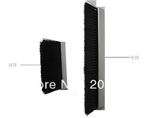

Escalator Safety Brush
0918.414.313 / meter
- 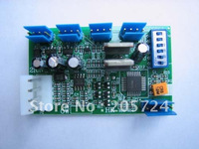

Otis RS14
0918.414.313 / piece

- 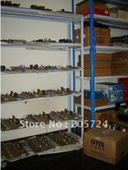

OTIS parts
0918.414.313 / piece

- 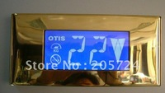

OTIS LCD display
0918.414.313 / piece
- 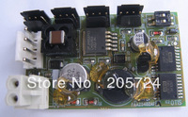

OTIS FAA25402AF1
0918.414.313 / piece

- 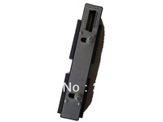

OTIS GAA22439E12
0918.414.313 / piece

- 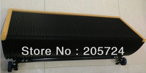

OTIS Escalator step 1000mm
0918.414.313 / piece
Min. Order : 2 pieces
- 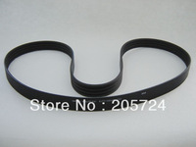

Presssure belt GCA717D1
/0918.414.313 piece

